- Unit Root Tests (on ORIGINAL DATA)
  - Graphical
    - Non-linear Trend in ACF

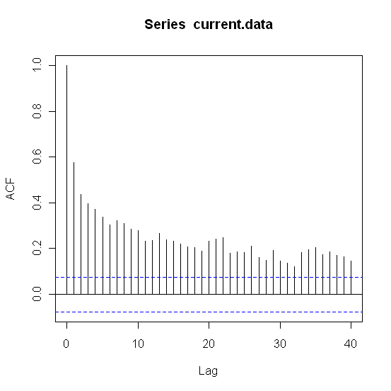
    - PACF Plot (to find lag)
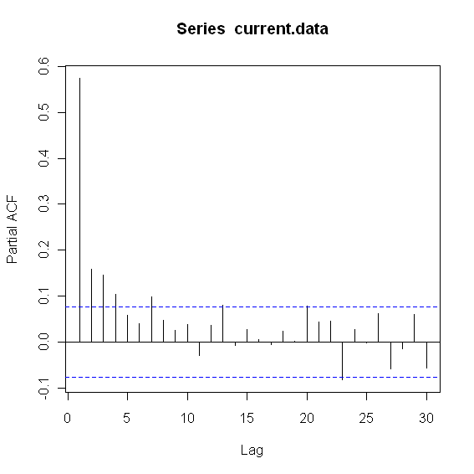
  - Formal
    - ADF w/ lag = 4 (H_{o}: y_{t} ~ I(1), unit root stationary, H_{a}: y_{t} ~ I(0), non unit root stationary)
    - ADF – CT (regression w/ constant (C) and trend (T))
      - Test Statistic = -6.6711
      - P-value = 0.01
    - Phillips – Perron (H_{o}: y_{t} ~ I(1), unit root stationary, H_{a}: y_{t} ~ I(0), non unit root stationary)
      - Test Statistic = -14.568
      - P-value = 0.01
      - Truncation lag parameter = 6
    - KPSS (H_{o}: y_{t} ~ I(0), non unit root stationary, H_{a}: y_{t} ~ I(1), unit root stationary)
      - Short truncation lag
        - KPSS Trend = 0.2972
        - P-value = 0.01
        - Truncation lag parameter = 5
      - Long truncation lag
        - KPSS Trend = 0.1437
        - P-value = 0.0542
        - Truncation lag parameter = 18

- ARMA / GARCH
  - ARMA Model
    - EACF Plot to determine ARMA order (also used ACF/PACF)
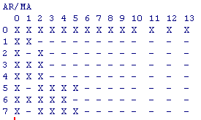

    - ARMA(2,1)

Call:
arima(x = current.data, order = c(2, 0, 1))

Coefficients:
ar1 ar2 ma1 intercept
1.2762 -0.3002 -0.8531 11.4878
s.e. 0.0715 0.0610 0.0537 0.1610

sigma^2 estimated as 0.4878: log likelihood = -703.14, aic = 1416.29

    - Box-Ljung Tests
      - Residuals of Nile Data
Q(12) P-value df
6.38 0.701 9

      - Residuals^2 of Nile Data
Q(12) P-value df
23.66 0.023 2

  - GARCH Model
    - GARCH(1,1) with ARMA(2,1)

Maximum Likelihood Estimation (Std.Errors based on Second derivatives)
Coefficient Std.Error t-value t-prob
Cst(M) 11.524248 0.11912 96.75 0.0000
AR(1) 1.000000 1.2918 0.7741 0.4391
AR(2) -0.106731 0.82108 -0.1300 0.8966
MA(1) -0.543666 1.4092 -0.3858 0.6998
Cst(V) 0.184434 0.13202 1.397 0.1629
ARCH(Alpha1) 0.142997 0.060934 2.347 0.0192
GARCH(Beta1) 0.488994 0.28470 1.718 0.0863

    - Box-Ljung Tests
      - Standardized Residuals of Nile Data
Q(12) P-value df
9.73 0.373 9

      - Standardized Residuals^2 of Nile Data
Q(12) P-value df
5.76 0.835 10

